Experiment No: 1

Experiment Name: Port Scanning Tools

Aim
To perform port scanning on a target system using Nmap and identify the open, closed, and filtered ports and the services running on them.

Procedure
- Open Kali Linux and launch the Terminal.
- Check whether Nmap is install
- Identify the IP address of the authorized target system
- Observe the Nmap results and note the PORT, STATE, ad SERVICE information.
- Record the open ports and their corresponding services.

Output
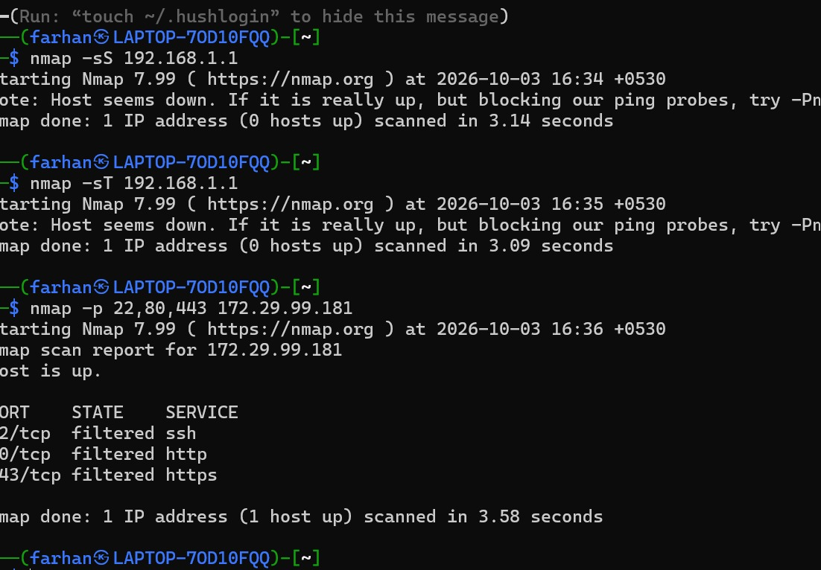

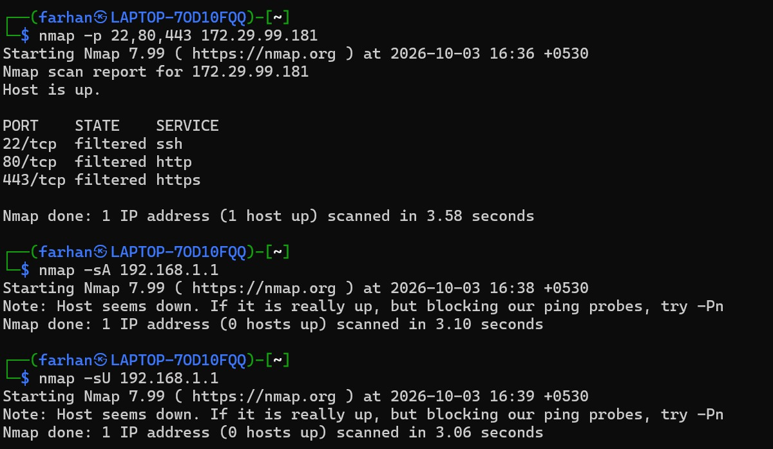

Result
Thus, port scanning was successfully performed using Nmap, and the open ports and services running on the authorized target system were identified.

